10 User Stories

1. As a user, I want to sign up as new member since I am a new user in this platform to get my own personal account.

2. As a user, I want to log in my own account for purchasing books and selling books in platform.

3. As a user, I want to contact seller to ask questions about book details when I am tending to buy that book.

4. As a user, I want to upload book information to sell my books which not in used and earn some money.

5. As a user, I want to find a book with filter to get my suitable book easily when I have no idea to choose the books.

6. As a user, I want to have recommended books from system to show me what did I viewed and interested recently.

7. As a user, I want to purchase a book and make payment through online method so that I can get my book with delivery.

8. As a user, I want to view purchase history and latest location when delivery to ensure my books are on the way.

9. As a user, I want to view promotions and vouchers to get discount for saving money when purchasing books.

10. As a user, I need to find a help when I was facing trouble in selling and purchasing using system.

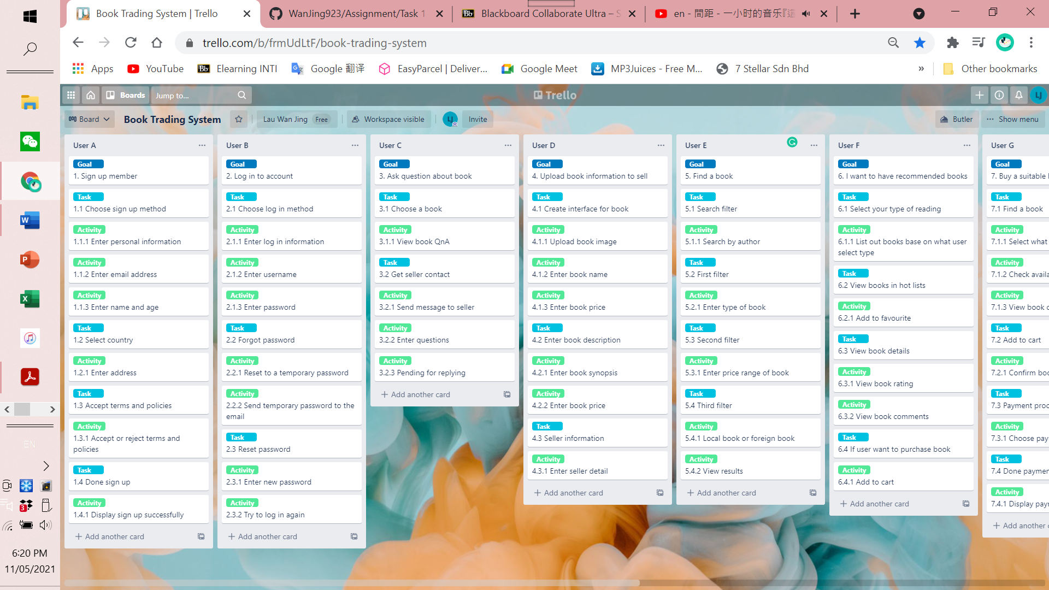

User story 1- User A

Goal: Sign up as member.

Enter personal information to register account.

User story 2- User B

Goal: Log in account.

Reset password if forgot password.



User story 3- User C

Goal: Contact seller to ask questions.

User story 4- User D

Goal: Upload book information for selling.

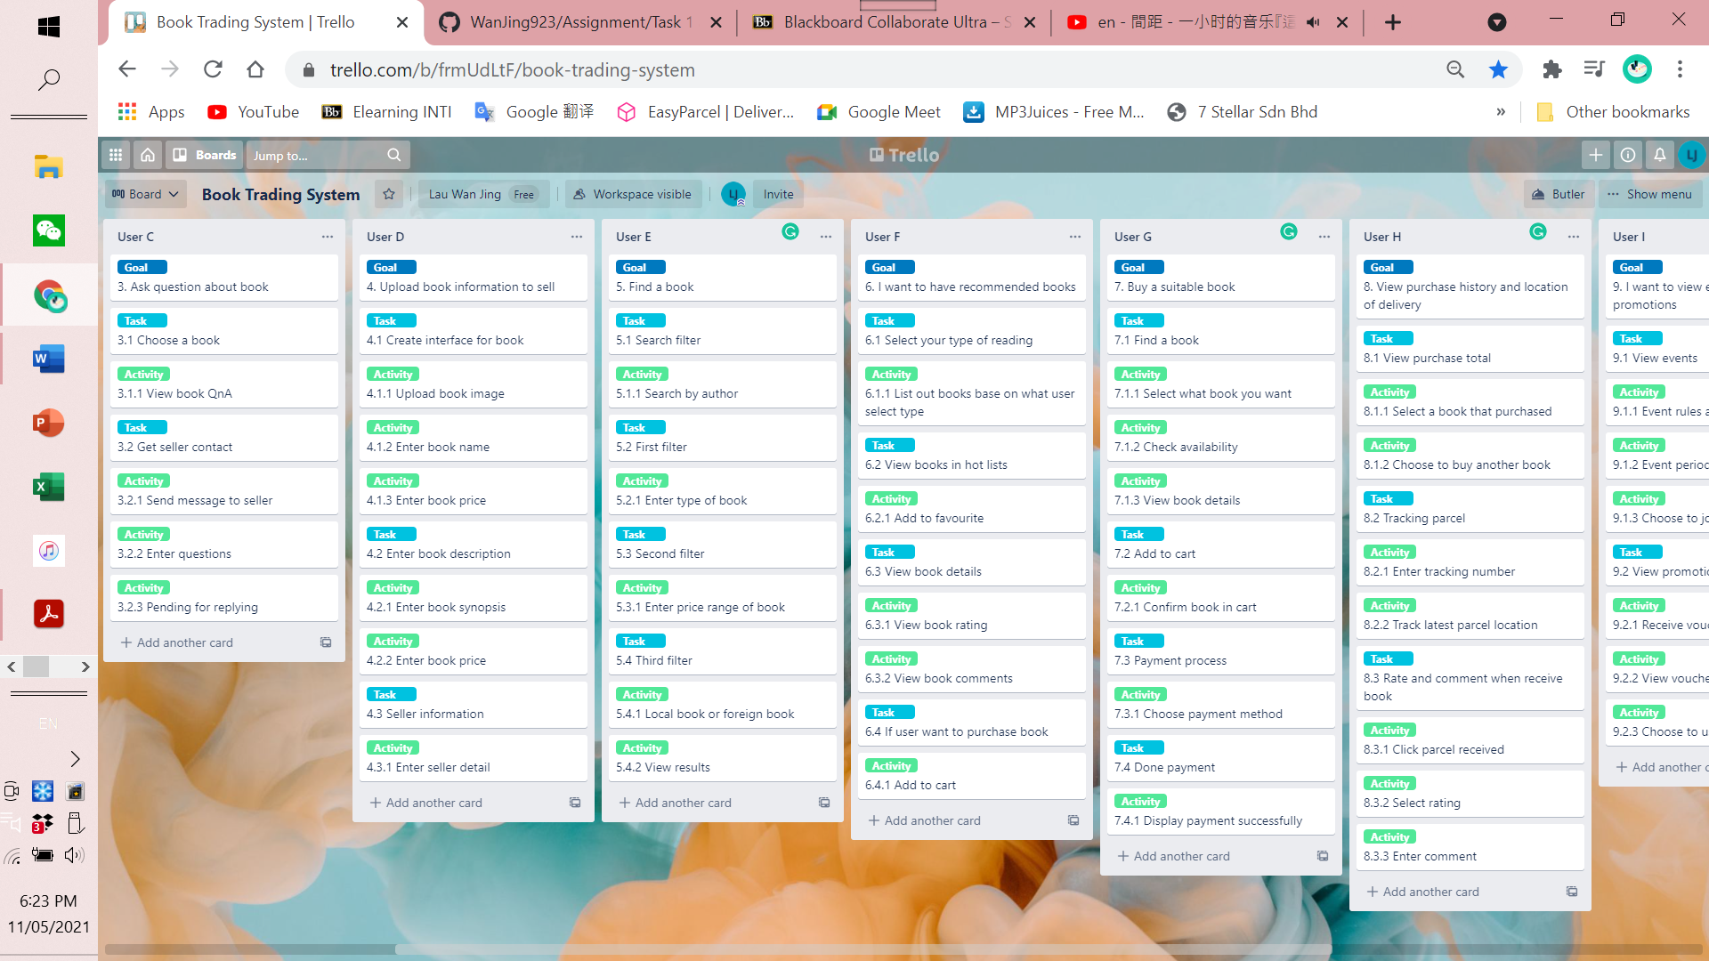

User story 5- User E

Goal: Find a book with filter characteristics.

User story 6- User F

Goal: Find book that recommended to read base on what users like.

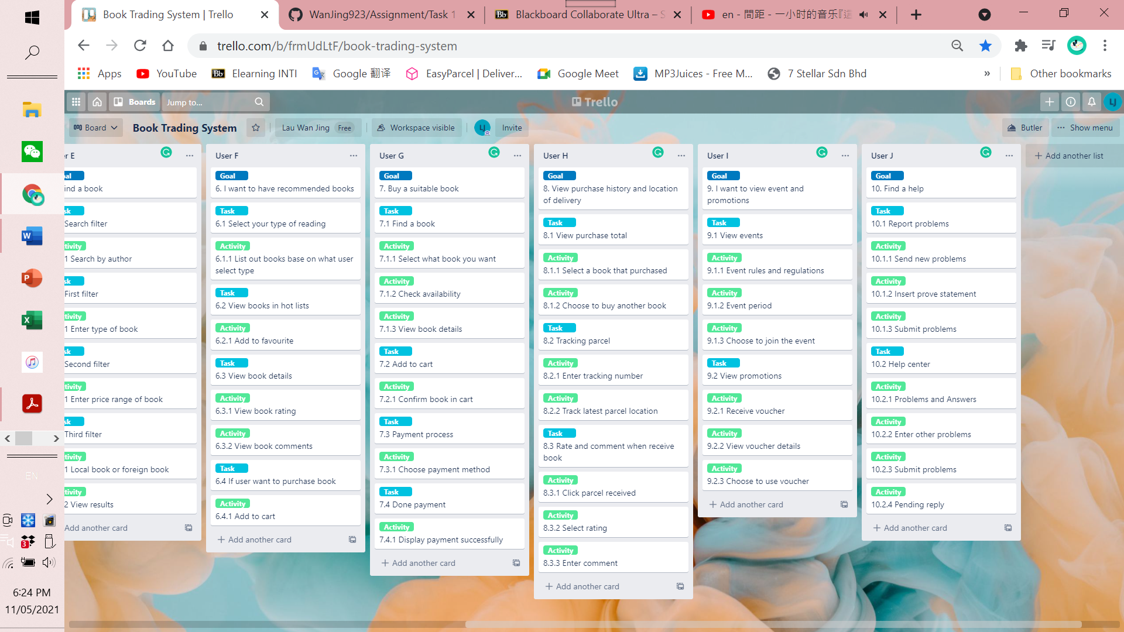

User story 7- User G

Goal: Purchase a book and done payment.

User story 8- User H

Goal: View my purchase history and track my parcel location for receiving parcel and give review.

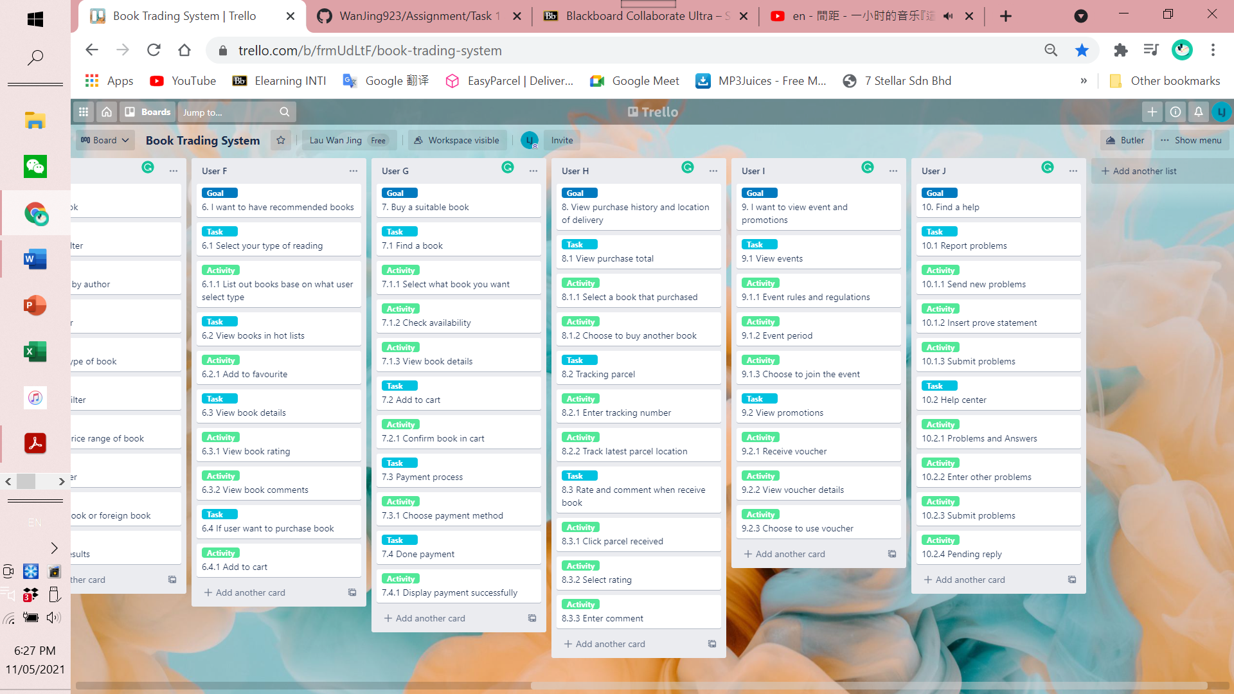

User story 9- User I

Goal: View events and promotions details.

User story 10- User J

Goal: Find a help from system when facing problems.